**Self-Advocacy and Human Rights**



What do we mean when we talk about self-advocacy?

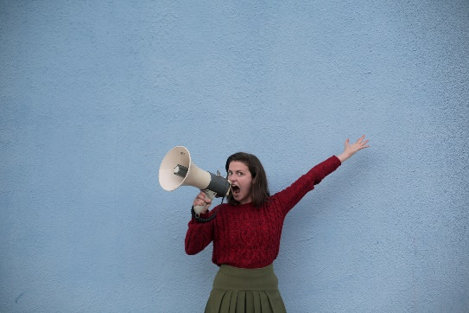

We self-advocate whenever we speak up for ourselves

and say to the world: -



**This is who I am.**



**These are the things that matter to me.**



**This is what I’ve been through in my life.**



**These are the things in my life that make me stronger and give my life meaning.**



**These are the things that have hurt me deeply.**

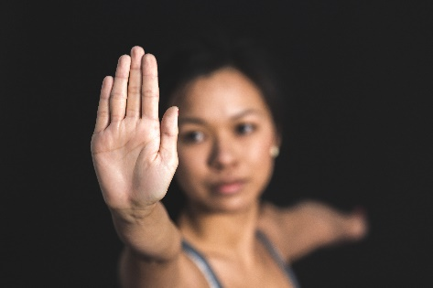

**This is what is OK and NOT OK in my life right now.**

and…



**These are the changes that must be made so that I have the life I want.**

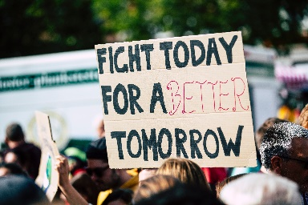Everyone has the right to speak up about what matters to them,

and especially to speak up about what is **not OK** in their lives.

Everyone has the right to speak up about the unfair things that happen

*  in workplaces
* in the community
* and in the way people treat each other.

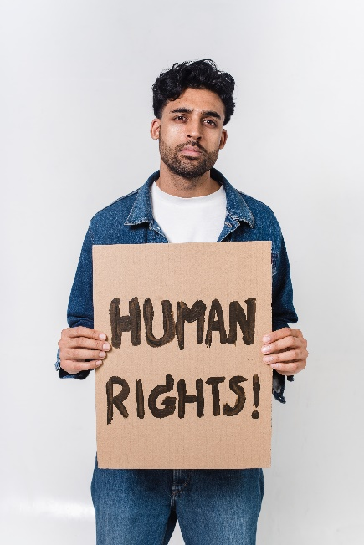

We all have the same rights:

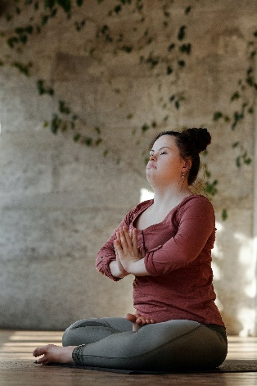

* The right to be respected as important members of the community



* The right to make our own choices about our life
* The right to be safe in our homes and in our community



* The right to receive an education



* The right to have opportunities to work and receive a fair income

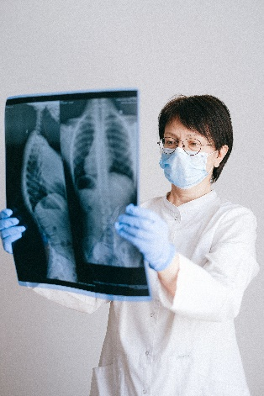

* The right to get healthcare and all those things that support a healthy life

Self-advocacy is about you speaking up because you have rights

- to be heard



- and respected.