Submission to the Discussion paper ‘Defining
Prohibited Practices for the Office of the Senior
Practitioner (OSP)

Impacts of defining Prohibited Practices
Advocacy for Inclusion (AFI) welcomes the opportunity to provide feedback to the proposal to define prohibited practices under the Senior Practitioner Act 2018 (The Act). We welcome the efforts by the Senior Practitioner to promote the reduction of restrictive practices in the ACT.
AFI is a human rights-based organisation, working to further the principles established in the international Convention on the Rights of People with Disability (CRPD). Australia is a signatory to the CRPD and therefore the ACT is bound to uphold the human rights obligations enshrined in that instrument.
AFI considers all use of restrictive practices, regardless of context or purpose as a violation of human rights. The CRPD establishes that people with disability have the right to:

- Equal recognition before the law (Article 12)
- Freedom from torture or cruel, inhuman, or degrading treatment or punishment (Article 15)

Additionally, the UN Special Rapporteur on Torture has condemned the use of restrictive practices in Australia. He emphasised that forced treatment of people with disability is inconsistent with the CRPD. The UN Committee on the Rights of Persons with Disabilities has called on Australia to end the use of restrictive practices.
This position is shared by peak disability organisations including People with Disability Australia and Women with Disability Australia. Similarly, in the ACT, disability organisations including ACTCOSS and Imagine More also advocate for the end of the use of restrictive practices.
In broad terms AFI believe that restrictive practices should be eliminated rather than identifying a list of specific practices to be eliminated. AFI is concerned that the creation of a prohibited practice list may create the impression that other restrictive practices are subsequently less severe, or more acceptable in usage. This may risk the violation of the human rights of people with disabilities in the ACT across a range of contexts. As a human rights jurisdiction the ACT has a responsibility to protect all people, especially people with disability and children from abuse. The discussions about restrictive practices must focus on elimination rather than regulation.
However, we do recognise that the establishment of a prohibited practice list is potentially a step towards eliminating restrictive practice. We encourage the Senior Practitioner to publicly commit to the continual expansion of the restrictive practices that fall within the prohibited practice list, with the aim of eliminating restrictive practices in the ACT.

AFI therefore recommends the implementation of the prohibited practice list alongside a robust campaign to ensure educators and service providers are aware of the serious nature of restrictive practices, notably the human rights impacts of such practices, and provide resources to assist them to transition away from restrictive practices within their service.
We also strongly recommend that the list of prohibited practices be continually updated to reflect the work of the office of the Senior Practitioner to eliminate restrictive practices in the ACT.
Finally, AFI recommends strong penalties for use of prohibited practices, or abusive use of restrictive practice. Our recommendations are outlined further below.
Recommendations:
- AFI recommends the prohibited practice list be introduced alongside a strong education and awareness campaign to make service providers aware of the consequences of restrictive practices and how they can eliminate usage in their workplace.
- AFI recommends the list of prohibited practices be updated and expanded on a regular basis to facilitate the gradual elimination of restrictive practice usage in the ACT.
  - That the list of prohibited practices by reviewed and expanded in light of findings from the Royal Commission into Violence, Abuse, Neglect and Exploitation of People with Disability
- AFI recommends that there is a public commitment to progressive expansion of the list of prohibited practices over time on a regular basis, towards an end goal of eliminating restrictive practices in the ACT

Recommended Inclusions to the list of Prohibited Practices

AFI endorses the sample list of restrictive practices which could be prohibited, as provided in the discussion paper. However, we also recommend the following practices be included on the list of prohibited practices included at the outset:

Incentivising and/or disincentivising a behaviour using financial rewards or punishments.
- This is practice of coercive control which impacts a person’s financial independence and capacity to leave an abusive or unsafe situation.

Force-feeding or depriving a child or young person of food.
- This practice is a prohibited practice in New South Wales and is considered unlawful to use in any circumstances to manage the behaviour of a child or young person. AFI recommends this practice be similarly prohibited in the ACT in order to prevent the traumatisation and abuse of children and young people.

Restraint and/or seclusion of children and young people

- AFI recommends the prohibition of restrain and seclusion of children, in line with recommendations from the federal peak body, Children and Young People with Disability Australia (CYDA). CYDA reports their members experiences of restrictive practices are most profound within the education system, noting that these practices cause ‘trauma and harm’ to students with disability. The use of restraint or seclusion violates a child’s fundamental right to bodily autonomy and integrity and potentially violates the child’s right to an inclusive education, and to have equal access to education. Restraining or secluding a child risks inflicting deep trauma, physical harm and has on occasion resulted in the death of a child. Further, a review of research on restraint and seclusion in schools indicates that such practices are being used to coerce or discipline students, out of convenience or as a means of retaliation.

Non-consensual or coercive sterilisation, menstrual suppression, contraception and abortion. Decisions to engage in these medical interventions must be made with the consent of the individual, using a supported decision-making framework if necessary.

- AFI endorses the recommendation from Women with Disabilities Australia (WWDA), in response to the Disability Royal Commission ‘Restrictive Practices’ issues paper. Use of restrictive practices on women and girls with disability is “a form of gendered ableist violence … restrictive practices violate, harm, dehumanise and segregate women and girls.” In their submission WWDA highlight that these particular restrictive practices are used on women and girls with disability for organisational reasons or convenience. For example, the use of contraception or sterilisation to negate the need to provide sexual education, giving menstrual suppression to avoid having to deal with additional hygiene needs. The practices above are serious medical interventions uniquely applied to women and girls with disability without their consent. AFI is calling for this practice to be prohibited in the ACT.

Removal of the right to communicate by removing peoples access to phones, mobile communication devices communications media, or augmentative and alternative communicative (AAC) devices.
- AFI notes that the removal of devices can represent a form of disconnection from family, financial control, navigation and spatial awareness and connection with social networks, health information, justice, and other formal and informal supports. It is an increasingly consequential and punitive form of restraint which links to the other forms of restraint. AFI notes that there are different considerations between care and education settings in respect of devices.

Practices related to degradation or vilification or humiliation.
For the avoidance of doubt, we suggest ‘Humiliation’ be covered in this section to provide for practices which viewed in isolation might not be seen as degrading or vilifying but are when viewed in context. For instance, singling people out for punishment in front of peers or requiring people to wear specific items of clothing because of an inherent characteristic.
Recommendations:
- AFI recommends that the following be added to the initial list.
  - Incentivising and/or disincentivising a behaviour using financial rewards or punishments.
  - Force-feeding or depriving a child or young person of food.
  - Restraint and/or seclusion of children and young people
  - Non-consensual or coercive sterilisation, menstrual suppression, contraception and abortion. Decisions to engage in these medical interventions must be made with the consent of the individual, using a supported decision-making framework if necessary.
  - Removal of the right to communicate by removing peoples access to phones, devices communications media, or augmentative and alternative communicative (AAC) devices.
  - Practices related to degradation or vilification or humiliation.

Penalties for the use of Prohibited Practices

Strong punitive measures must be in place for using a prohibited practice, or a restrictive practice outside of the scope of the ACT. These must apply to both the individual using them as well as the provider organisation. These penalties must correspond with the severity of the actions which have occurred. Use of restrictive practice violates the human rights of people with disabilities. Penalties under the act must be a strong deterrent for violation of The Act and prevent future violations of The Act.
It is the view of AFI that use of prohibited practice, or restrictive practice outside the scope of the The Act, constitute criminal assault and subsequently warrant the same response as if the assault had occurred in a public setting. While we have not sought legal advice, we see no reason why use of these violent actions should not be considered criminal behaviour and referred to police.

We recommend that these measures include reporting individuals to AHPRA or the oversight body relevant to their practice. Specifically, that the Senior Practitioner write to AHPRA or an equivalent body to inform them that the individual has been found to use prohibited or restrictive practices in violation of ACT law – and request that AHPRA list these findings publicly with the details of that individual’s registration. This allows people with disability, or their family and carers to ensure that their individual providers have not previously been found to use prohibited practices or restrictive practices in violation of ACT law.

There must also be strong accountability measures for the management staff of provider organisations where use of prohibited practice occurs. Service provider organisations found to use prohibited practices must have appropriate restrictions placed on their capacity to register positive behaviour support plans. We recommend detailed record keeping of any findings against service provider agencies, and revoking support plans if providers consistently fail to ensure the safety and human rights of people with disability.

Recommendations:

- AFI recommends that use of prohibited practice or restrictive practice outside the scope of the Senior Practitioner Act be reported to the police. Especially if these acts are violent in nature or would be commonly considered assault in if they occurred in a public setting.
- AFI recommends that the Senior Practitioner report individuals who use prohibited practices or restricted practices outside the scope of ACT law to AHPRA or their relevant regulatory body.
  - That in these instances the Senior Practitioner request AHPRA list the findings of the Senior Practitioner publicly alongside that individual’s registration details.
- AFI recommends that service provider organisations who are found to have used prohibited practices must have appropriate restrictions placed on their capacity to register positive behaviour support plans.
  - This must include details and record keeping of service providers who violate the Senior Practitioner Act or regulations underneath it.

List of recommendations
- AFI recommends the prohibited practice list be introduced alongside a strong education and awareness campaign to make service providers aware of the consequences of restrictive practices and how they can eliminate usage in their workplace.
- AFI recommends the list of prohibited practices by updated and expanded on a regular basis to facilitate the gradual elimination of restrictive practice usage in the ACT.

  - That the list of prohibited practices by reviewed and expanded in light of findings from the Royal Commission into Violence, Abuse, Neglect and Exploitation of People with Disability
- AFI recommends that there is a public commitment to progressive expansion of the list of prohibited practices over time on a regular basis, towards an end goal of eliminating restrictive practices in the ACT.
- AFI recommends that the following be added to the initial list.
  - Incentivising and/or disincentivising a behaviour using financial rewards or punishments.
  - Force-feeding or depriving a child or young person of food.
  - Restraint and/or seclusion of children and young people
  - Non-consensual or coercive sterilisation, menstrual suppression, contraception, and abortion. Decisions to engage in these medical interventions must be made with the consent of the individual, using a supported decision-making framework if necessary.
  - Removal of the right to communicate by removing peoples access to phones, devices communications media, or augmentative and alternative communicative (AAC) devices.
  - Practices related to degradation or vilification or humiliation.
- AFI recommends that use of prohibited practice or restrictive practice outside the scope of the Senior Practitioner Act be reported to the police. Especially if these acts are violent in nature or would be commonly considered assault in if they occurred in a public setting.

- AFI recommends that the Senior Practitioner report individuals who use prohibited practices or restricted practices outside the scope of ACT law to AHPRA or their relevant regulatory body.
  - That in these instances the Senior Practitioner request AHPRA list the findings of the Senior Practitioner publicly alongside that individual’s registration details.
- Service provider organisations who are found to have used prohibited practices must have appropriate restrictions placed on their capacity to register positive behaviour support plans.
  - This must include details and record keeping of service providers who violate the Senior Practitioner Act or regulations underneath it.

Endorsements
This submission is endorsed by:

ACT Council of Social Service

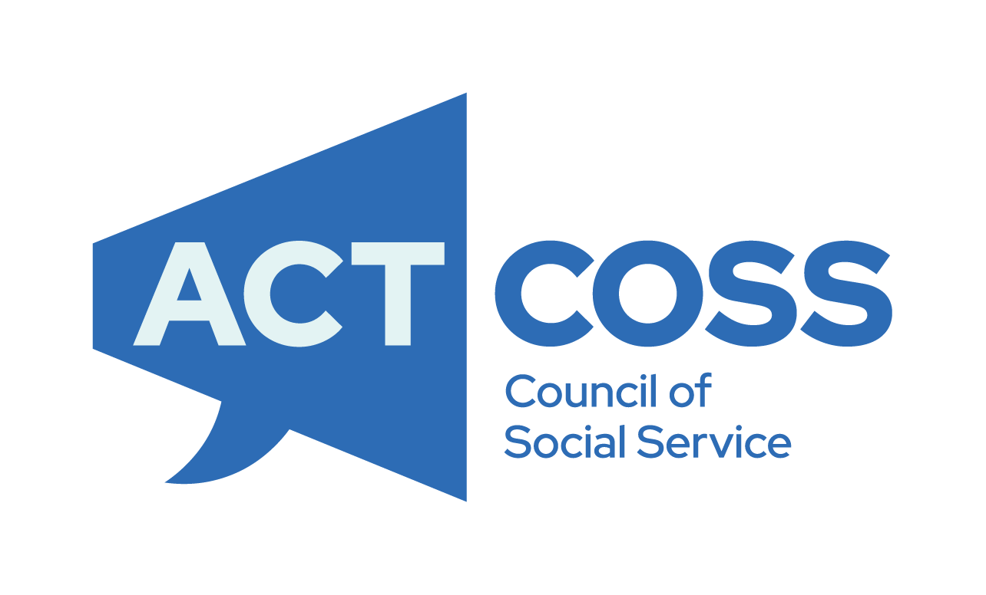

Imagine More
.

For contact regarding this submission please contact Isabel Moss, Policy Officer at isabel@advocacyforinclusion.org or Craig Wallace, Head of Policy on 0477 200 755 or craig@advocacyforinclusion.org

United Nations Department of Economic and Social Affairs Article 12 – Equal Recognition Before the Law, available: https://www.un.org/development/desa/disabilities/convention-on-the-rights-of-persons-with-disabilities/article-12-equal-recognition-before-the-law.html
United Nations Department of Economic and Social Affairs Article 15 - Freedom from torture or cruel, inhuman or degrading treatment or punishment available: https://www.un.org/development/desa/disabilities/convention-on-the-rights-of-persons-with-disabilities/article-15-freedom-from-torture-or-cruel-inhuman-or-degrading-treatment-or-punishment.html
Factsheet: Forced Treatment and Restrictive Practices - Disabled People's Organisations Australia (DPO Australia)
ibid
Submission on Restrictive Practices Authorisation in NSW - People with Disability Australia (pwd.org.au)
Women with Disabilities Australia (WWDA) (2021). ‘Response to Restrictive Practices Issues Paper of the Royal Commission into Violence, Abuse, Neglect and Exploitation of People with Disability’. July 2021, WWDA: Hobart, Tasmania.
Disability | ACT Council of Social Service Inc. (actcoss.org.au)
Gatekeeping and restrictive practices with students with disability: results of an Australian survey - Imagine More
Restricted and prohibited practices - Positive behaviour | Caring for Children (nsw.gov.au)
Children and Young People with Disability Australia (2019) ‘Restrictive Practices Authorisation in New South Wales’
ibid
McCarthy, T (2018) Regulating restraint and seclusion in Australian Government Schools, A Comparative Human Rights Analysis, QUT Law Review Volume 18, General Issue 2 pp. 194–228ISSN: Online–2201-7275
McCarthy, T (2018) Citing multiple sources
Ibid
Women with Disabilities Australia (WWDA) (2021). ‘Response to Restrictive Practices Issues Paper of the Royal Commission into Violence, Abuse, Neglect and Exploitation of People with Disability’. July 2021, WWDA: Hobart, Tasmania.
Ibid page 58, paragraph 5.1
Ibid page 58 paragraph 5.8

